Social Media Guide: Electric Vehicles
MESSAGING: GENERAL ELECTRIC VEHICLE (EV) EDUCATION
General information is great to share on social media. Even if it seems basic, this knowledge can go a long way to gaining support for electric vehicles in your community!
Sample posts
- Are you interested in learning more about the electric vehicle options out there? EVs come in many shapes & sizes; sedans, hatchbacks, minivans, and SUVs to name a few! https://bit.ly/2K2FEo3 #DriveElectricMN
- From summer road trips to winter commuting, electric vehicles and plug-in hybrids come with the battery range and road safety you deserve. Need some inspiration? Read about this family’s trip up north. https://bit.ly/2LPIqyX #DriveElectricMN

- Check out all these electric vehicle (EV) chargers in Minnesota! Thanks to @plugshare you can start planning your EV route now. https://www.plugshare.com/ #DriveElectricMN

- Did you know that fully-electric vehicles (EVs) with the smallest range on the market today can easily go more than 100 miles on a full charge? Plug-in hybrid EVs have the same range as any vehicle AND the option to drive fully electric. https://bit.ly/2K2X0Bj #DriveElectricMN

- Electric vehicles provide many benefits beyond cleaner air; they will save you money and time over the life of the vehicle. https://bit.ly/2MncVMh #DriveElectricMN

- Electric vehicle charging infrastructure is already in place in Minnesota to support your driving needs—more is being added all the time! Check out this interactive map to find fun activities near MN charger stations! https://bit.ly/2kpZIGX #DriveElectricMN

- Concerned about winter driving in an electric vehicle? Don’t worry, EVs can often perform better in icy conditions compared to gasoline vehicles due to the more consistent acceleration and lower center of gravity. https://bit.ly/2hHaDHc #DriveElectricMN

- Cleaner air, healthier communities, +$$ savings from lower fuel costs and fewer maintenance needs—check out all the benefits of driving an electric vehicle! https://bit.ly/2K2X0Bj #DriveElectricMN

MESSAGING: GENERAL EVENT PROMOTION
If you are hosting an EV event like a showcase or an information session, here are some sample social media post so your audience has all the information they need. Make sure you are clear on what, when, where, and costs (especially if it is a free event!). The following posts are meant to be tailored to your unique event.
- Did you know that by 2040, estimates indicate that 55 percent of all new vehicle sales will be electric? Jump on the bandwagon and learn more about electric cars at [Insert event information]. #DriveElectricMN

- Electric vehicles (EVs) come in many shapes and sizes—sedans, hatchbacks, minivans, and SUVs to name a few! Explore the variety and find your perfect fit at the [insert event information]. #DriveElectricMN

- Electric vehicles are better for the environment and better for your wallet. Test drive one this month at the Ride and Drive! [insert event information]. #DriveElectricMN

- What is a Ride and Drive event? It’s an opportunity for you to test drive different makes and models of electric vehicles, for free! Our event will also include guest speakers, charging information and more! [insert event details]. #DriveElectricMN https://bit.ly/2jWYouT

- Curious about electric vehicles but not sure where to start? Join [insert organization name] for a chance to test drive the [make and model]. This event is FREE and will be hosted at [location] from [time]. [event URL] #DriveElectricMN

- Don’t forget to join us for our upcoming Ride and Drive Event on [day and time]! This is your chance to get behind the wheel of the electric [make and model]. Register now! [event url]. #DriveElectricMN
TIPS
- Share educational resources from http://www.driveelectricmn.org/electric-vehicles/ to help answer questions beforehand and create interest in your event.
- Respond to social media comments and inquiries as soon as possible.
- Use a URL shortener like https://bitly.com/ on Twitter to shorten the number of characters used in your posts
- If you created a Facebook event, make sure to update it with additional details as they are finalized. Periodically share and post in the event page.
- Use these hashtags:
  - #DriveElectric
  - #DriveElectricMN
  - #EVs
  - #ElectricVehicles
  - #ChargeForward
  - #RideAndDrive
- Use these images or the image pulled from the URL/web link you are using to help your post get attention.
- Tag you partner organizations and Drive Electric Minnesota (Facebook @DriveElectricMN; Twitter @DriveElectricMN) in your social media posts. This helps your post get more views and lets your followers know about your collaborative efforts!
- When taking photos at the event, make sure to get permission to use the image on social media from the people prominently featured in the shot.

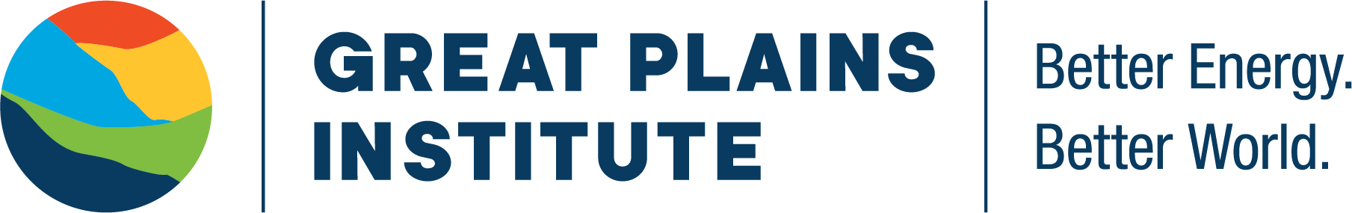

Drive Electric Minnesota is facilitated by the Great Plains Institute, a nonpartisan, nonprofit organization transforming the energy system to benefit the economy and environment. Working across the US, we combine a unique consensus-building approach, expert knowledge, research and analysis, and local action to find and implement lasting solutions. Our work strengthens communities and provides greater economic opportunity through creation of higher paying jobs, expansion of the nation’s industrial base, and greater domestic energy independence while eliminating carbon emissions.

Learn more at www.betterenergy.org.

